IKEA’S INTERNATIONAL MARKET ENTRY PLAN

Student’s Name

International Marketing Management
Professor’s Name
Westford University College
Date
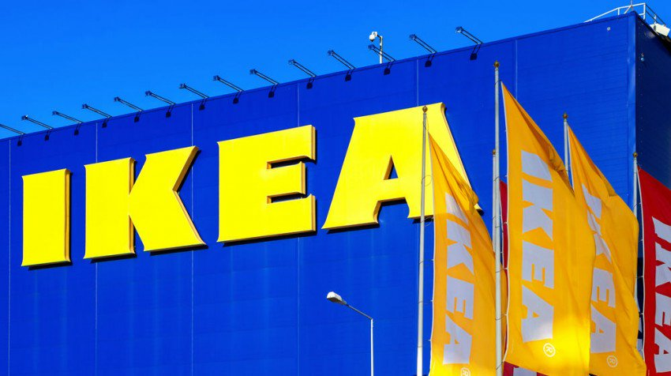
Executive Summary
IKEA is a global furniture corporation that seeks to offer its loyal customers with fashionable handy product offerings with simple lines, which are produced at low costs with suppliers, and are lowly priced such that a majority of individuals can afford the products. The company's vision goes over and beyond house furnishings, as they want to be accessible and expand using their resources. More global shoppers than ever before can now shop in an IKEA store. The first store was situated in Serbia and was also the 400th internationally. At the end of 2017, IKEA had 403 stores in more than 49 nations. Even though the European markets have had a boom in IKEA stores as there are over 275 stores in Europe, Australia has only ten across the country mostly near the large cities. The potential for new customers' growth and increased market share is massive in Australia. In light of this, an international market entry plan will be elaborated and advised through the suggestions in the report to build IKEA's customer-base in Australia's market. IKEA can implement the marketing tactics to have a successful expansion into Australia. The marketing plan will emphasize on IKEA differentiating itself to lure the Australian consumers along with tailoring the current marketing strategies that the firm has to promote its awareness in Australia.

The selected business is IKEA; a company is famous for its D.I.Y conception which makes it the autonomous furniture retailer globally. The first scope of the discussion will highlight the firm's marketing processes and its segmentation, target segments, and positioning strategies based on their IKEA’s standards using diverse methods and means of implementing the concepts. The report will also highlight IKEA's current situation and an in-depth marketing strategy analysis. Secondly, IKEA's marketing mix and strategies on how the firm will use their 7Ps' in the expansion plan will be highlighted in the report. Lastly, through the application of the scenario of international expansion, with a focus on Australia, this report provides a detailed analysis of IKEA's present business environment and marketing processes and strategies. Through the use of various models and tools (SWOT, PESTLE, Porter's, BCG Matrix, Ansoff's Matrix, and Product Lifecycle) the objective is to apply marketing theory into practice in competitive markets by developing effective marketing strategies.

The objectives for the international marketing plan is to expand IKEA's brand into the Australian markets, increase brand awareness in Australia by 40 percent in 1 year, and obtain 5% of the total market share by the end of 2018. To sum up, the focus of the report is to analyze the impact of the dynamic business environment globally on the marketing management functions of an organization. A marketing plan for international expansion will be developed with the application of suitable marketing models and techniques. The marketing processes in the management of brands and how their effect on consumer behaviour will be discussed in the paper. Marketing strategies are explored, barriers that might hinder expansion, as well as the factors that influence the entry mode into the Australia markets, are highlighted in the report.

Table of Contents
Executive Summary 2
Introduction 4
Background Information 4
Company Background 5
Application of Theory into Practice 7
Current Situation Analysis 7
Market Analysis 7
Consumer Analysis 8
Competitor Analysis 8
Marketing Strategy 8
STP Model Analysis 10
Segmenting Analysis 10
Targeting Analysis 11
Positioning Analysis 12
Marketing Mix 12
Product 13
Price 16
Place 18
Promotion 20
People 22
Processes 23
Physical Evidence 24
Marketing Models tools and techniques 25
Porter’s Model 25

Ansoff’s Matrix 30

Recommendations 32
Conclusion 32
References 36

IKEA’s International Expansion Plan
Introduction
Background Information
In the past two decades, globalization has occurred at faster speed. There are some factors that have enhanced the choices of being globalized namely, liberal trade policies, financial transactions’ stability, and the likelihood of continual flow of products between nations, and major innovations and progression in communications, technological advances, and transportation (Theodosiou & Leonidou 2003). The changes have generated numerous ways of delivering products across their nationwide boundaries, hence growing intense competition (Craig & Douglas 1996). But, the active processes of transmitting the elements of the marketing, the marketing mix, through different nations is still the focus of discussion (Seggie & Griffith 2008). Changing environments in the international markets has necessitated marketing managers to face the problem of designing marketing strategies that are suitable for global markets. This discussion has been supportive in the evaluation of the effects of domestic market adaptations against prospective benefits that the firm can realize through the implementation of standardized strategies in cross-national segments (Katsikeas 2006; Sousa & Bradley 2008).
Conventionally in Europe, the children inherited furniture and household goods from their parents. But, globalization and modernization have altered the consumer purchasing patterns. Jonsson (2008) cited that the younger populations are disposed to purchasing low cost and modern portable furniture and furnishing merchandise. Thus, the international retailer has deliberately design a product range that caters to the younger target consumer markets, promote decreasing costs through streamlining its processes with resident suppliers (Kristoffersson 2014). The firm is an exemplary illustration of a firm that has restructured the industry regarding the activities of its supply chains. IKEA has in the past effectively applied its business model in many nations in Russia, Europe, MENA and North America (Jonsson 2008).
This paper seeks to determine how IKEA can define its position in its sustained international expansion with a focus on Australia. First, the report highlights a broad literature review on the company background and international expansion. Second, the report shows in-depth analysis and critique of the company's present business environment, target market segmentation and marketing processes. Thirdly, the paper reveals IKEA's marketing mix and strategies on how the firm will use their 7Ps' in their expansion plan. Next, various models and tools (Porter's Model and Ansoff's Matrix) will be used to apply marketing theory into practice by determining IKEA's trends and growth patterns used in the development of strategic marketing strategies for the Australian markets. Besides, IKEA's challenges and barriers in penetrating Australian's home furnishing markets will be addressed fully in the report. Lastly, the paper offers recommendations for devising innovative marketing strategies that will contribute to the growth, expansion, and higher revenue streams.
Company Background
IKEA is a multinational group of companies that sell a wide array of furniture, home furnishing, and household wares. The firm designs and sells DIY furniture, home appliances, and other accessories via its unique design stores and annual catalogues. IKEA is renowned for its contemporary architectural designs linked to being eco-friendly and combining low pricing with top-quality product offerings, in alluring store settings (Reynolds 1988). As at August 2017, IKEA owned 403 stores in 49 countries and is about 1% of the global commercial products' wood consumption. In 2017, IKEA retails business segment generated €38.30 billion in sales, which infers there are more exquisite bedrooms, beautiful kitchen fittings, appliances, and smarter storage than before.
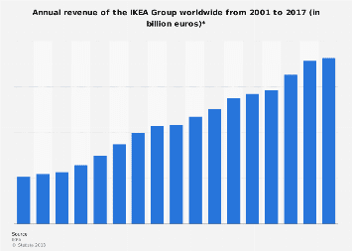
IKEA group’s Annual Revenues 2001 to 2017
The multinational corporation was established in 1943 by Ingvar Kamprad from South Sweden (Kristoffersson 2014). The business name is an acronym that constitutes Ingvar Kamprad (founder's names), Elmtaryd and Agunnaryd where the "E" and "A" letter are Elmtaryd, a farm where Ingvar was raised and Agunnaryd, Ingvar’s hometown (Dahlvig 2012). Initially, the core business entailed selling postcards, pencils, and other merchandise as a mail-order business. In 1948, Kamprad commenced discovering pioneering solutions like the DIY furniture designs, and effective advertising. These expansions were fruitful and popularized owing to IKEA's unique products and reasonably priced household furniture. In 1953, IKEA circulated its first ever annual catalogue, and its preliminary showcase was opened at Kronoberg in Sweden (Torekull & Kamprad 2011).

Application of Theory into Practice
Situation Analysis
The situation analysis is a comprehensive report on IKEA's present state including its customers, key competitors, and marketing strategies that contribute to the success and competitive advantage in the market industry (Seggie & Griffith 2008). STP analysis will be applied to accomplish the situation analysis.
Market Analysis: Australia signifies one of the more mature markets that offers favourable growth. This can be attributed to the rapid increase in the population and real estate infiltration to accommodate the individuals. This has resulted to an increasing need for home appliances and furniture for the new houses along with renovations to keep up with the state-of-the-art functionalities and technologies. Companies that provide innovations like IKEA with a higher degree of energy efficiency, low prices, and multi-utilities are undergoing enormous demand which in turn, offer massive potential to the home products market in Australia. The appliances and furniture markets are expected to grow in retail volume terms continuously, and the growth was driven by home renovations, new technologies, and augmented disposable incomes.
Consumer Analysis: Women have a highly dominant role in household decisions in Australia which gives IKEA an extra advantage to target the market. The consumers frequently use online shopping and social media to seek advice and product reviews from other shoppers when they are making their purchasing decisions. In Australia, the mid-and-upper classes are augmenting the spending power of the national economy which, in turn, promotes development in the country. The median age range is about 27 years old, so there is need to focus on the age group as it constitutes working young people who live alone or have young families. IKEA sells a majority of its products to individuals who are homeowners and need products that are elegant, functional, and affordable to fill their households (Håkansson & Waluszewski 2002). This age group contains budget-conscious individuals as they are working for families with young school- going children. Thus, the Australian shoppers are possibly women and young down-to-earth, relaxed, reasonably fashionable and generally "thrifty" consumers.
Competitor Analysis: IKEA implements a global pricing strategy to maintain cost leadership in its markets and in-house production efficiencies that are greater than the competitors. In Australia, IKEA will be a market leader in discounted furniture and home appliance in five years, though other retailers also provide similar affordable products. IKEA's most significant source of competition in Australia includes discount department stores, Crate & Barrel, Bed, Bath N Table, Mydeal.com, Fantastic Furniture, Urban Outfitters, and Betta Home Living. The competitors offer different styles and functionality features. Though, IKEA stands out due to its unbeatable prices without compromising the quality. Also, most of the competition relies profoundly on web-based marketing, but IKEA will have an edge as it uses a combination of digital and printed catalogues. IKEA has a huge advantage for the firm's catalogue which has proven over time to be a useful promotional tool that continuously evolves and improves (Edvardsson & Enquist 2011). The firm can use its catalogue to test its new Australian markets in new locations and enhance its brand awareness.
Marketing Strategy
IKEA's present marketing strategy is exclusively based on building strong relationships with its consumers (Dahlvig 2012). Similarly, IKEA's marketing strategy applies a hands-on and multimedia methodology in comparison to its competitors. The firm launched IKEA Home Tours, "First:59" campaign, and Share Space to have a well understanding of its consumers' needs as the media allow the firm to interact with its brands on a personal level and at all times. The company believes that the most important factor when marketing to consumers is to have an enhanced understanding of the current market needs and meeting the customer's desires. IKEA's marketing strategy also emphases on the IKEA brand having the perception that it is affordable, well-designed, and functional products that are family-oriented and innovative.
The catalogue is used as the primary source for printed advertising. The 300-page catalogue was launched in 1951 and is published in over 38 editions, 18 languages and disseminated in over 28 countries. Over the past four decades, IKEA has evolved digitally by the implementation of a YouTube Channel in all nations as well as the creation of an interactive web version of its catalogue and "Easy to Assemble" web series (Kristoffersson 2014). Some of the activities that allow IKEA to differentiate itself and compete effectively are its core competencies. IKEA's main competencies focus on cutting costs, thus competing based on prices and design. Other competencies are limited Customer service by having catalogues, helpful labels, self-transport and DIY assembly; self-selection; Low manufacturing costs; and modular furniture designs.
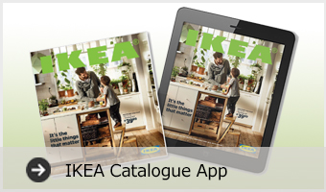

Segmentation, Targeting and Positioning Model
IKEA's segmentation, targeting, and positioning model involve a group of ensuing marketing decisions that encompass the core marketing strategies. The STP marketing is a three-phase approach used in devising the targeted marketing plan which allows IKEA's marketing function to formulate an effective marketing strategy that links the firm, its brands and product benefits to specific customer market segments.
Segmentation: This section highlights the segmentation themes in IKEA's target market: geographic, demographic, psychographic and behavioural segmentation. The geographic theme is based on the locality statistics where IKEA's customers are centered. Diverse regions have dissimilar backgrounds that are dependent on the activities of the geographical units which are done to accommodate the local conditions (Kerin Hartley & Rudelius 2010). IKEA mainly is subdivided into geographic segmentation of the European, American, and Asian markets. The sales revenues in the Scandinavian zone accounts for 80 percent of total sales, trailed by North America zone which constitutes 15%, the remainder 5% caters for Asia and Australia.
The demographic theme is an objective attributes theme that is based on the income level, race, and occupations. IKEA applies demographic segmentation which constitutes individual age groups, gender orientations which are based on family life-cycle, income level, occupation, social interactions, and economic factors. The females with average ages of 38 years frequently visit IKEA stores. Recently, the firm also targets young couples who own apartments, first-time furniture shoppers, working professionals, and young married adults who are overly price conscious as they have limited budgets and need value for their hard-earned money.
The psychographic theme is a personal attribute theme that is based on traits and personal demands, lifestyle, customer's behaviour, shared activities, personal beliefs and views. In the European and North American markets, the customers select products that are simple designs, but the durability of furniture start to wear-out, they can be substituted at any time based on preferences, demands, and lifestyle trends ((Kristoffersson 2014). However, in Asia, the customers opt for home decorations in the pursuit of a luxurious lifestyle, mainly when deciding to buy bulky furniture. The psychographic theme focuses primarily on the customers' attitudes on the beneficial purposes they make purchases, their frequency, and reasons for buying the products which in turn have a profound impact of consumer behaviour, demand, income range, prices, and consumers' attitudes. IKEA's markets are subdivided into income scopes from the low, middle-income, and high-income classifications.
Targeting: Each of IKEA's groups need to be targeted and marketed directly to persuade the customers to remain or be loyal to the brand. The first target is women of any age, one of the tactics used is social networking via Facebook which allows its customers to connect and collaborate with the company. One of IKEA's noticeable traits is that the women primarily direct conversation on Facebook. IKEA also has a "family-oriented" idea, whereby the parents drop their kids off at a childcare center inside the IKEA stores, and the firm has incorporated the "IKEA Children" in their product offerings. Hence, IKEA is a one-stop-shop for mothers who want to upgrade their children's rooms.
The other target group is the youth. The young families and persons grow as they acquire more belongings and furniture. IKEA recognizes the fact that there is a growing market of young professionals and growing families. One of the ways that IKEA targets the tech-savvy youth is through mobile marketing, and the catalogue is readily available at no cost on the Android and iPhones. This mobile-convenience keeps the commuting professionals busy for subway rides to work. The final target audience is the low-income families group. Virtually everyone wants to save money to nurture the vital things in the lives in the tough economy. IKEA offers lowly-priced and quality household merchandise for families and persons without an unlimited budget.
Positioning Strategies: These are strategies that are used in the creation and maintenance of the product philosophy, activities, and decisions in the customer's minds. The positioning mechanism is used to distinguish products along the dimensions, features, or value from the competitors. The positioning strategies used by IKEA is the differentiation, cost leadership, shopping experience, and functional and simple designs (Bengtsson 2008).
Evaluation of IKEA’s Marketing Mix
From the analysis in the preceding sections, IKEA's marketing team propositions to target new international market segments and potential customers are primarily located in Australia. The marketing team considers that the new market segments comprise IT savvy young adults and highly-educated adults with higher income levels. These market segment appears more profitable and can enhance the revenues and profits from the new market segments. The Marketing Mix can be defined as a group of well-regulated variables that firms can apply to influence the response of the buyers (Kotler & Armstrong 2018). Each firm endeavours to build up the composition of 7‘P's, which creates the highest consumer satisfaction levels while at the same time meeting the organizational objectives.
Traditionally, the considerations were referred to as the 4Ps namely, the products, price, promotion, and place. As marketing evolved into a mature field, an additional fifth ‘P' was included — People. Recently, two extra ‘P's were included — the Processes and Physical evidence (Bowman & Gatignon 2010). Therefore, the 7-Ps marketing mix is amassed bearing in mind the target customers' needs and varies from one company to another depending on the existing resources and marketing objectives.
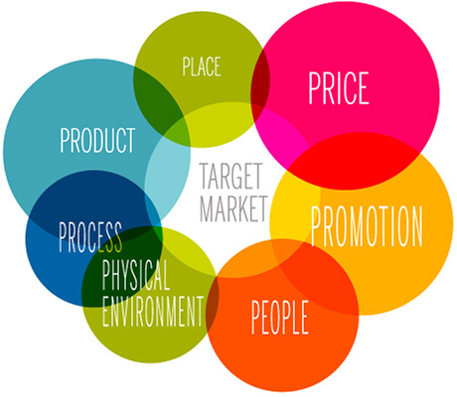
Product: Product denotes the goods and services that are offered by organizations since they fulfil one or more of customers' needs. The customers pay for the benefits provided by the products and not for the tangible products (Pride & Ferrell, 2014). So, the products can be designated as a package of benefits which the marketers offer to the consumers for a price. IKEA offers a wide array of products and should continually produce and sell its product offerings. There are over 9500 products, and IKEA renews its product ranges by launching about 2,500 products annually. The in-house and contracted designers usually design these products. The furniture giant adheres to five scopes of democratic design: form, high quality, functionality, sustainability and low prices (IKEA 2012). The firm sells home products for the living room, lounges, bedroom, bathrooms, kitchens, home appliances, textiles, carpets, and rugs, and other corporate and seasonal items.
Similarly, IKEA's primary focus is on price reduction during the development and manufacturing as it develops products that match the prices the firm envisages. This is achieved by collaborating with suppliers, capitalizing on the production process, applying the technical innovations, improving designs' efficiency, and minimizing wastes. For the Australian markets, IKEA has released their ‘flexible furniture ‘for renters who are seeking to make the most of their minimal space and life on the go. With a majority of home renters and small city living, home space is at a premium. Hence, the adaptable furniture will come in handy. Similarly, as part of the developing trends, IKEA's latest range features some coffee tables that have basket compartments, sofa seats with storage and racks that are designed to store numerous items such as magazines, books, or towels. There are stackable beds in the range, which constitute the conversion into double beds and two single beds.
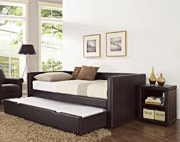
Sofa Seat with storage
One of the most common IKEA products that came to mind is the BILLY bookcase. The product is so modest, so simple, and devoid of style yet, 60 million Billy bookcases have been sold internationally—representative of one per cent of the population of the world (Bengtsson 2008). Though it debuted over forty years ago, and its look has changed minimally over time, one could not tell the dissimilarity between a bookcase sold in 1980 and one sold in 2018, the BILLY bookcase is still the bestselling bookcase historically, and the sales are even stronger now than they were when the bookcase first hit the markets (Harford 2017). From a product manager's viewpoint, the BILLY bookcase sensation offers some valuable lessons. For instance, the lack of a distinctive style has given the IKEA bookcase a longer shelf life. IKEA deliberately designed the BILLY bookcase to be neutral furniture, without unique style. Another benefit of the product strategy was that the bookcase could fit attractively into any interior of any office or home, irrespective of the style or theme (Kristoffersson 2014). BILLY bookcase has clean lines and a neutral look which infers that the bookcase can last longer in all environments, even as the styles, tastes, and trends evolved.
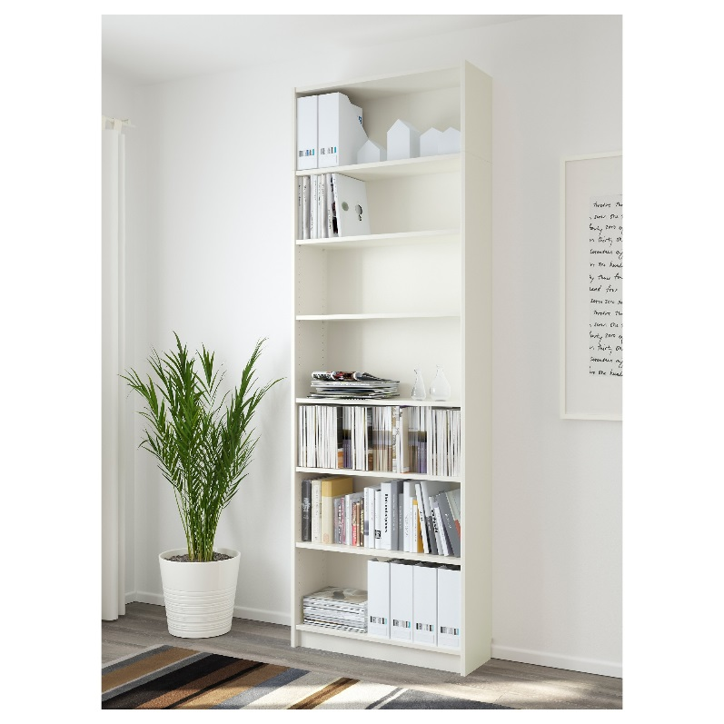
Also, the BILLY's bare-bones style permits IKEA to sell the bookcase at lower prices. A remarkable aspect of the IKEA product experience is the DIY. This explains why the BILLY has had sound success for four decades as the firm uses particleboard, MDF, lighter, and engineered products which allow IKEA to manufacture, transport and store the BILLY units inexpensively. Lastly, all products make an implied promise to its customers. Marketing managers should decode the hopes that their products cause to its customers, and if there are some elements of like the design, packaging, and features that would be stripped away without damaging the promises. If one can achieve that, then the products should be less costly to manufacture and more affordable for the customers. For the BILLY bookcase, the promise is an absurdly simple and ludicrously inexpensive shelf to store and display the books. All else is stripped away even the costs of producing the bookcase (Harford 2017).
Price: Price is defined as the amount charged for products. It is ranked as the second most significant component of the marketing mix. Fixing the prices of products is a tricky process as it entails considering numerous factors such product demand, costs involved, customer's ability to pay, prices levied by the competitors for the same products, taxes, and government restrictions (Sousa & Bradley 2008). The pricing decisions are crucial decisions since it has a profound impact on the demand for the products and overall profitability of the firm. IKEA's products are commonly charged in accordance to the balance of affordability by its consumers for them to readily make purchases and determining the number of sales achieved by IKEA which realizes the firm's profitability target to their objective. In theory, there are some long-term strategies regarding pricing that has been implemented by IKEA which include the profitability achievement for the impending investments. Pricing is maintained within reasonable ranges to ‘shut out' the competition, and the proficiencies of maximizing the sales revenues targets through the pricing contemplation. The firm reduces lower prices in numerous ways such as economies of scale and minimal packaging (Torekull & Kamprad 2011).
The short-term pricing tactics assumed by IKEA include promotional offers and sales which encompass various pricing aspects such as penetration pricing where the firm set reasonable prices to invade the industry. The firm employs destruction of pricing, "Price Wars," where IKEA reduces its prices to a degree of eliminating competition in the industry. Lastly, promotional pricing where the sales pricing is placed to a level of the satisfaction of the consumers through special offers to allow them to make purchases within their budgetary expectations. IKEA designs its collection of home products from the onset with affordability in mind but continues the practice throughout the products' life cycle by constantly lowering prices annually (Kristoffersson 2014). Psychological pricing is also an important feature of IKEA's pricing strategy in that the retailers appeal to emotion, as opposed to rational customer decision-making. The firm applies the Price Point Perspective 0.99 Cents rather than 1 Dollar for most of its products.
Place: The products are manufactured and traded to consumers should be availed to consumers at a location where they can appropriately make purchases. The place also involves a series of individuals and organizations, channels of distribution, such as the distributors, wholesalers, brokers, and retailers who encompass the distribution networks (Australia & Ronkainen 2013). The company has to decide if to sell directly to retailers or through distributors and wholesalers. The firm can also plan to sell to its consumers directly. IKEA is famous for their competitiveness and their innovative outcomes. It manufactures a restricted quantity of products and depends on its network of suppliers. The products through suppliers can create exclusive atmospheric designs that feature environmentally friendly materials and efficient use of resources (Carlsson 2015).
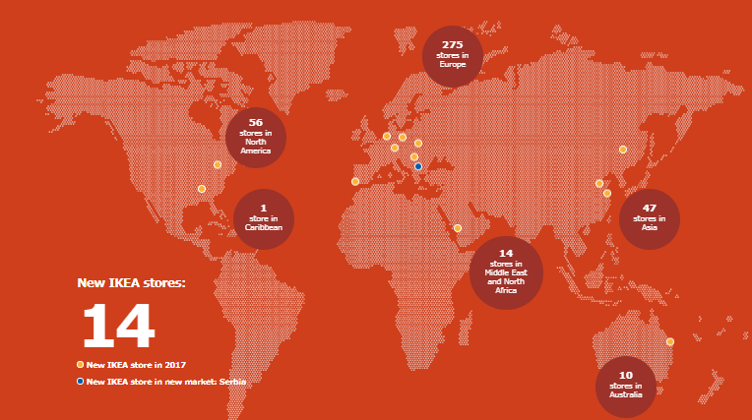
IKEA’S Stores
Ikea has publicized massive international expansion plans by opening dozens of stores in the Australia market. IKEA has more than four decades of Australian home furnishing experience. At present, there are 10 IKEA's stores in Australia located in Rhodes, Adelaide, Perth, Marsden Park, Springvale, Canberra, North Lakes, Richmond, Logan, and Tempe. The Swedish furniture giant has revealed plans to open over 30 new stores in Australia by 2030. The number of stores could be even more significant if other ‘small format' stores can be opened inside the shopping centers. IKEA international expansion plan presents a huge challenge for distribution, and the adaption to the future demands consistent adaptations to its distribution structure. One of the future challenges is technology as shoppers opt to order custom-made designs online. E-shopping and telephone orders are on the rise, which necessitates flexible and efficient distribution solutions toward each surpassing the customer's expectations.
IKEA's focus is customer fulfilment which presents abundant possibilities. Technology has been used to make the customer experience as seamless as possible by the introduction digital screens for the IKEA business, payment methods, mobile apps, and digital catalogues. The old business model involved taking the shoppers to the IKEA retail outlets, however since the business environment has transformed and a majority of customers prefer to shop online and IKEA outlets (Reynolds, 1988). Thus, the IKEA brand has been availed through the creation of different formats and ways of doing business. The customers can presume to see fewer assistants at checkouts in favour of a highly "seamless" online ordering, touchscreens and self-service experience. In addition to the10 stores, IKEA has in the recent past launched an e-shopping platform in various collection points in Northern Territory, Queensland, Canberra, Tasmania, and Sydney. In 2017, IKEA opened a $150 million distribution unit in Marsden Park to support the shopping experience.

Promotion: One the products are manufactured bearing the consumer's needs in mind, is correctly priced and availed at outlets or platforms that are convenient but the consumers are not made aware about the products' prices, features, and availability, then the marketing effort might not be fruitful (Pride & Ferrell, 2014). So, promotion is another essential ingredient of the marketing mix as it is the process of notifying, persuading and compelling consumers to make choices of the product to be purchased. The promotion aims to offer information to potential consumers about the products' availability, features, and uses as well as arousing possible consumer's interest, making comparisons with competitors' and make a choice. The explosion of print and electronic media has enormously facilitated the promotion. Promotion is useful in publicizing the new business, particularly in foreign markets where the consumer already has local brands they trust.
In all advertisements from different countries, IKEA continually displays slogans connected to its products and IKEA. IKEA has various slogans and advertising approaches which are adapted to the culture of the country. IKEA has also shown high profile advertising campaigns which include online advertisements. In the Australian markets, some of the techniques for enhancing publicity comprises sponsorship for events functions that are frequented by target audiences such as dinner and dance, fashion shows, and wedding functions where IKEA provides furniture. The company could also conduct customer surveys periodically which allows the organization to get customers feedback with the viewpoint of improving customer retention. The customers are the greatest ‘judiciary' function of products, and their suggestion can aid in making adjustments on products accordingly. Similarly, customers are also the best source of deriving new innovative ideas that can be implemented by the business (Bengtsson 2008). By observing objectively and subjectively customers can suggest new propositions to improve a product or propose new products that would be beneficial to the company and other consumers. Next, IKEA can organize weekly or monthly tours to allow its customers to understand their products by explaining the means for saving space and convertibility.
A direct marketing strategy via the website provides a seamless online shopping experience. The catalogue is a type of direct marketing that allows the consumers to purchase their products instantly. The IKEA catalogue is distributed annually and has been the marketing tool of the Swedish furniture giant which spends 70% of yearly marketing budget in printing the catalogues (Torekull & Kamprad 2011). The catalogues are availed online, retail outlets and mailing to households. Also, since a majority of Australian families have internet access provides the opportunity to promote their business online through the IKEA website, which is custom-made for each nation. The viewers can view see various products, their prices, feature, and descriptions, just as the shoppers would if the catalogues were delivered at their doorstep. Online media, mobile apps, and the websites can be used to promote the discounts, offers, and events online. The apps can also provide a platform for ordering and tracking deliveries.
Besides, sales promotion strategies can be used when customer purchase the first item; they could get a gift card or other items. Also, office and family gifts and gift vouchers can be bought over the counter at discounted prizes. Buy one get one free promotion can be piloted every six months for the clearance sale. Also, purchases over a fixed amount can automatically have 30% off discounts. IKEA can be official sponsors for various shows where participants can grasp and go items over a certain amount (like $500). Shoppers can apply for IKEA's loyalty program membership online and accumulate points for redeeming the items in stores. Other ideas for sales promotion can be the grand openings of the new stores with superior deals. The newspaper adverts and coupons that target the young adults are other sales promotion ideas. The coupons that inspire individuals to BYOF (Bring Your Own Friend), is another idea since gives off a youthful vibe as long as the Australian markets are open to the translated message. This will aid in driving massive traffic throughout the stores and collection points, spreading the word among families and friends which gives IKEA a free promotion platform.
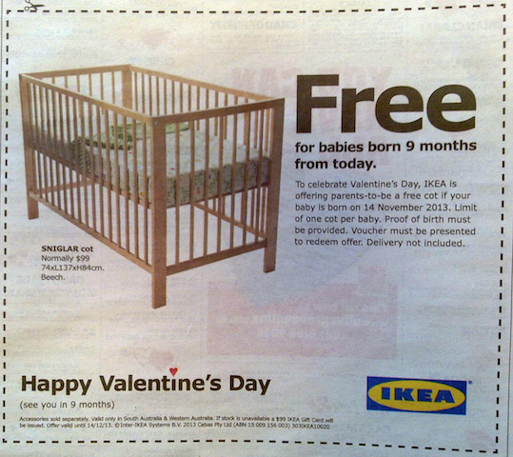
People: Anybody who comes into contact with the consumers can give an impression that has a profound impact-positive or negative - on the level of customer satisfaction. Thus, the brand image and reputation rest in people's hands. It is vital to ensure that the employees are trained, well-motivated and have the right attitude. People are essential since a majority of customers cannot separate products from the staffs who provide them. After sale support and the product advice supplied by the business can add immense value to the product offerings, and give an edge over competitors (Seggie & Griffith 2008).
IKEA concentrates on the creation of "strong partnerships with customers," and pays a lot of attention to its personnel and organizational structure. The business keeps its management structures flat as there are no barriers between the management and co-workers. The shoppers seek more and more cost-effective quality designs, so the store personnel is trained expansively and given initiatives to serve the customers. IKEA also has an emphasis on the service feature of its competitive business as it seeks to build and nurture stronger relationships with customers to enhance customer satisfaction (Dahlvig 2012). Working and serving people is fundamental to IKEA's business model. The business has launched many energy-saving substitutes to conventional light bulbs. Their kitchen appliance's range also provides smart and eco-friendly product solutions such as water-saving kitchen taps, cooking appliances and specialized systems that can sort different household wastes ready for handling and recycling. IKEA's commitment is to decrease the environmental effect of its business on individuals and the environment. IKEA acts responsibly by using its resources competently in a bid to lower costs and enhance sustainability (Carlsson 2015).
Process: The processes of giving services, and behaviour of those who make deliveries is central to customer satisfaction. The issues like waiting time, the information offered to the customers and staff helpfulness are essential to the customer's experience (Pride & Ferrell, 2014). The customers are not keen on the details of the business operations. They want a system that works. Another vital component in the total service methodology used by IKEA is the focus on its processes. IKEA provides a convenient self-service shopping technique that lets customers view furniture set up in a store environment and move through the stores to a central hallway to make the purchase. After checking out form the stores, IKEA offers home delivery for its consumers who cannot carry the purchased items. Online media, mobile apps, and IKEA websites provide a platform for ordering and tracking deliveries from the stores to the doorstep. The creation of a streamlined experience and focus on the delivery of the low-cost products ensures that all customers are satisfied with the products and the shopping experience.
Physical Evidence: The last expanded marketing mix component is physical evidence, which constitutes all the tangible items used in connection with the products offered by the company (Seggie & Griffith 2008). In addition to IKEA's catalogues and other brochures, the firm maintains a meek, contemporary look in its stores with abundant showroom space for viewing furniture as it may look at home or in the office. The physical evidence is also IKEA'S huge stores located out of town and provide an enormous selection of a wide array of furniture products. The stores are well-equipped with baby care units, restaurants, ample parking, vast spaces, and simultaneous display technologies. The physical items make the consumers identify the IKEA brands and relate it with higher-quality home products and pleasant purchasing experience. Interestingly IKEA's business model encompassed sustainability early in its core strategy. A majority of its product range is eco-friendly and recyclable as the firm has invested in green energy solutions like solar power (Torekull & Kamprad 2011).
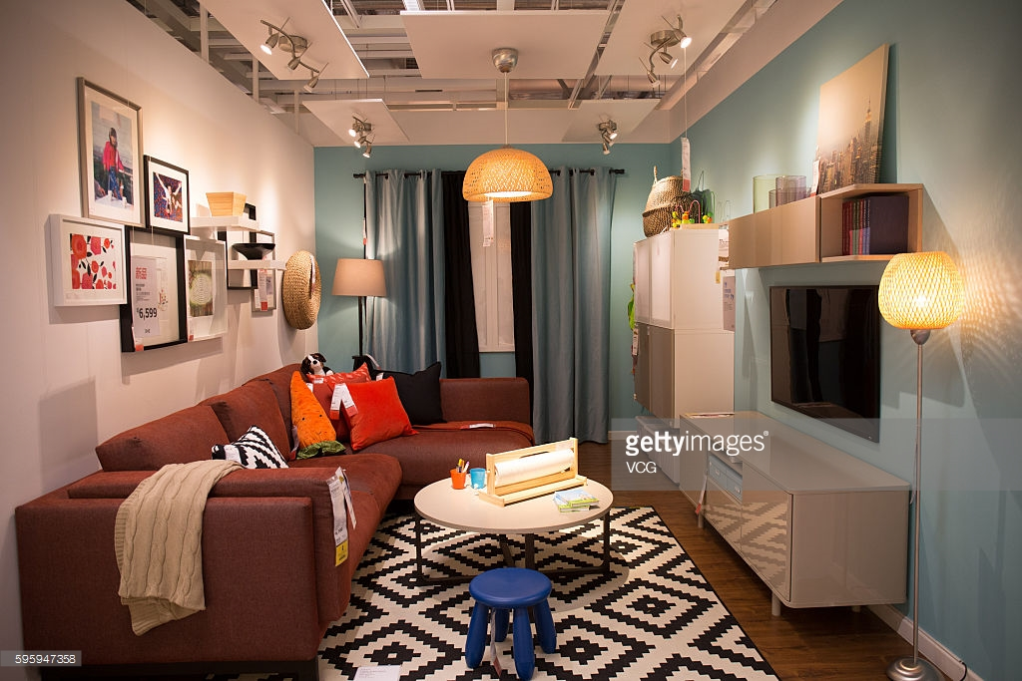

Marketing Models, Tools and Techniques
Porter's Model: The Porter's five-force analysis is a charter that tries to analyze the degree of competition in an industry and the development of business strategy. The framework draws on industrial organization economics to develop the five forces that regulate the competitive strength and then an industry's attractiveness. Porter developed the Five-Force analysis as a response to the then-popularized SWOT analysis, which Porter found arduous and ad hoc. Porter's five forces have been applied to a varied range of problems, from supporting businesses to become more profitable and helping the government to stabilize the industries (Cateora, Gilly, Graham, & Money 2016). The five forces constitute three forces from the 'horizontal-based' competition: the threat of substitute products, the threats of established rivals, and threats of new entrants; and the forces from 'vertical-based' competition: bargaining powers of suppliers and bargaining powers of customers. IKEA's Porter's Five Forces analysis is discussed in the following manner.
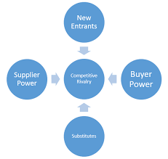
Rivalry among existing firms: Here, the competition amongst the current companies is intense in the international markets of discounted furniture and home furnishing industry. The major industry players include Wal-Mart Stores, Euromarket Designs, Galiform PLC, Argos among others. But, presently IKEA is the undoubted market leader of consumer discount and low-cost within the industry of discounted household furniture in the worldwide scale (Dahlvig 2012). In the global furniture industry brands, the rate of growth in the sector is not considerable, and this further exaggerates the level of competition amongst the existing market players. The bulk of brand stores, supermarkets and hyper supermarkets like Wall Mart, Tesco, Target, and Sainsbury's also sell some forms of household furniture, appliances, and home accessories. Besides, IKEA's direct global competitors include but are not restricted to Argos, Rooms to Go and Ashleys Furniture. Furthermore, there is a growing number of resident and small-scale furniture producers that pose stern competition to IKEA as well as giant online retailers like Alibaba, Amazon, and eBay.
IKEA's most significant source of competition in Australia includes discount department stores, Crate & Barrel, Bed, Bath N Table, Mydeal.com, Fantastic Furniture, Urban Outfitters, and Betta Home Living. The competitors offer different styles and functionality features. Though, IKEA stands out due to its unbeatable prices without compromising the quality. Also, most of the competition relies profoundly on web-based marketing, but IKEA will have an edge as it uses a combination of digital and printed catalogues. IKEA has a huge advantage for the firm's catalogue which has proven over time to be a useful promotional tool that continuously evolves and improves (Edvardsson & Enquist 2011). IKEA's prevalent and reliable brand image, marketing strategies and other factors such as affordable pricing strategies have facilitated the firm to gain a significant market share and customer base. These positive factors appear to moderate the level of competitive threats from the other furniture brands.
The threat of new entrants: The threats into the furniture and household wares and appliances industry are low, and the odds of occurrence of new rivalry for IKEA is insubstantial since the current markets are saturated, and substantial amount of expertise, financial and capital investments are prerequisite to being a discounted furniture retailer in an international scale. Industries that have high-profit margins usually attract other companies to gain entry into its market. Consequently, in the short-term, the new entrants that cannot withstand the rivalry will exit and the industry's profit margin remains unchanged. Nevertheless, in the long-term, the new entrants will participate in sharing of profit margins; later reduce the other companies' profits to break-even.
There are minimal legal and regulatory barriers to gain entry into the industry, and the knowledge barriers are not considerable. But, new market entrants might not benefit from the economies of scale to a similar degree as IKEA during the early stages of core operations. The right to use to distribution channels and the capital requirements also signify essential barriers for the new market entrants. There are new brands that can enter on a lesser scale, but they will not have any profound impact on IKEA's business as it takes time, efforts, skills, and investments to grow to a massive global brand and tap into a more significant market share. On top of infrastructural needs, and human resources, innovations, research and development and strategy can be time-consuming and need hefty financing. Besides, marketing is yet another vital cost along with operations. Hence, the barriers to entry are low. However, there are still many significant barriers that act as an obstacle to becoming an excellent and well known global brand because these factors curtail the threats from the new players in the industry keeping it at a low level.
Bargaining power of buyers: The bargaining power of IKEA's consumers is intense. This can be attributed to the fact that the competition within the industry is intense and the customers have a more extensive choice of substitute options provided by international furniture retailers and domestic furniture producers. Customers in all industries have become more empowered in the recent past, so there is need to focus on enticing and retaining the customers. In addition to the increased competition, the latest technological advances and growth have brought significant changes, and the balance is now lopsided in the customer's favour. IKEA focuses profoundly on its marketing, advertising, and promotions (Bengtsson 2008). While IKEA's pricing strategy is tailor-made to suit its customers' pockets, the firm also focuses on online marketing and e-commerce to create a pleasant shopping experience. Generally, the buyer's bargaining power can be agreed upon as strong. The various factors that can be applied to moderate the buyer's bargaining power are IKEA's low prices, high quality of products and effective marketing strategies.
The threat of direct substitute products or services: IKEA's threat of substitute products is low since there are no many products in the markets available that can be bought to substitute the demand for furniture, household appliances and other home accessories sold by IKEA. Some factors can be applied to moderate the threat. Simultaneously, one can argue that swelling numbers of online-based applications and internet products signify an indirect form of substitution for some products that are sold by IKEA. For instance, the increasing acceptance of e-books shrinks the demand for the IKEA shelves such as the BILLY bookcase to a certain degree (Harford 2017). But, the lack of switching costs for the customers to indirect substitutions increases the threat.
First, IKEA's brand image and has been built in the past nine decades. IKEA has fabricated a reliable and robust brand image whereby the trust levels between the consumers and the IKEA brand is quite high. Similarly, the firm's affordable and cost leadership pricing strategy and superior customer service moderate the threats from substitute products. Nevertheless, the most significant factor is the accessibility of an enormous range of products sold under one roof. Barely one of the IKEA's competitors provides such a broad range of products. Hence, these factors and IKEA's popularity, its products minimize the threat.
The bargaining power of suppliers: IKEA's suppliers do not have considerable bargaining powers since there are plentiful factories globally with the competencies, expertise, and resources to form viable partnerships with IKEA. All at once, IKEA also pursues an effective strategy of creating long-run strategic relationships with its network of suppliers The bargaining power of suppliers is low in the case of IEA since while their number of suppliers is large, the small size and weaker monetary position does not permit them enough influence. IKEA can readily switch from a supplier to another while if the suppliers lose business from the company, then it can be a problematic situation for the supplier. IKEA sets the guidelines of the game, and the suppliers are expected to follow. Besides, IKEA has also generated code of conduct for the firm's suppliers known as IWAY (Torekull & Kamprad 2011). The suppliers are responsible for the communication of the code of conduct to sub-suppliers. To ensure and guarantee the quality of its products, IKEA conducts over 1000 audits annually and repeatedly checks for any form of violations. The company has also formed rules connected to child labour, discrimination, minimum hours, minimum wages and secure working environment and the suppliers ought to comply, or else they can be removed. Apparently, the IKEA brand has the upper hand over its suppliers.
Ansoff’s Matrix: Successful company leaders comprehend that if the business is to expand in the long-term, they cannot stick with to the "business as usual" mentality, even though things are going well. The leaders need to devise new ways of increasing profits, market share and reaching new customers. There are abundant options available, like developing new types products or identifying new markets. The Ansoff’s Matrix is used to highlight the possible risks of the available options, and to aid in devising the most appropriate plan. The Ansoff Matrix was established by Igor Ansoff and published at first in 1957 in the Harvard Business Review (Australia & Ronkainen 2013). Over time, the matrix has provided generations of business leader and marketers leaders a quick and modest way of thinking about the possible growth risks. The Matrix as shown below demonstrates four strategies use to grow a business and helps in the analysis of the risks related to each one. The notion is that every time one moves into a new quadrant either horizontally or vertically, the level of risk increases.
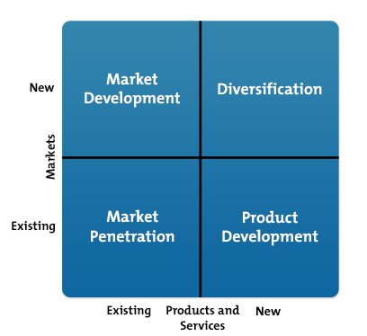
Market Penetration: Existing Products in the Existing Markets: In this case, market penetration is all about selling more of the existing products to a company’s existing markets. This can be achieved with a bid to penetrate and expand the customer base in a firm’s existing markets so the company might opt to cut its prices, enhance its distribution networks, invest heavily in the marketing initiatives, and increasing current production and operational capacity (Cateora, Gilly, Graham, & Money 2016). Also, the firm even tries to maximize the usage of distribution channels through making lucrative deals with a variety of distributors which include supermarkets, branded stores, and other retail outlets.
Product Development: Creation of New Products for the Existing Markets. The development of products is about the design, development, and sale of new products to be sold in the existing markets. Businesses can make some alterations in their current products to offer increased value to entice its customers to make a purchase or create and introduce new products together with the current product offerings (Kerin et al., 2010). Companies are compelled to invest heavily in Research and Development to come up with newer and advanced products every so often.
Market Development: The Existing Products in the New Markets: Here, the development of markets is about vending more of the firm’s existing products in new markets. The strategy entails reaching out to new customer segments and expanding internationally though targeting more modern untapped geographic markets (Katsikeas 2006). If the company’s products are doing exceptionally well in a market, there is the need to attempt to enter new markets with similar products.
Diversification of New Products in the New Markets: These diversification strategies encompass entering into new markets using new products that can either be related or entirely unrelated to the existing product offerings (Czinkota & Ronkainen 2013). Diversification can be categorized into three forms of diversification strategies. Concentric diversification which constitutes gaining entry into the new markets with new products that are slightly related to the firm's existing offerings. Next, the conglomerate diversification encompasses entering new markets with new products that are entirely unrelated to the firm's existing product offerings. Lastly, the vertical diversification infers moving backwards or forwards in the value chain while taking control of over activities and operations that are outsourced to other third parties such as distributors, suppliers, and OEMs.
Ansoff’s Matrix Summary
By applying the Ansoff's Matrix to IKEA’s case, IKEA should use a market development strategy by selling existing products in new markets as it has done in the past eight decades to be one of the leading low cost and discounted furniture retailers globally (Dahlvig 2012). Ikea began expanding to into markets reasonably close to Sweden regarding local culture as its home country before targeting the challenging geographic nations like China and Middle-East. IKEA has used its Eclectic paradigm, OLI Framework as a tool for determining how to gain entry into its foreign markets. IKEA has created a robust competitive advantage over home decor and furnishing markets through providing unique, low priced, and highly differentiated products (Kristoffersson 2014)
Conclusion and Recommendations
IKEA is a multinational group of companies that sell a wide array of furniture, home furnishing, and household wares. The firm designs and sells DIY furniture, home appliances, and other accessories via its unique design stores and annual catalogues. IKEA is renowned for its contemporary architectural designs linked to being eco-friendly and combining low pricing with top-quality product offerings, in alluring store settings IKEA is the sole retail outlet that specializes in the design and furniture products that comes to mind when equaling their high-quality and affordable furniture. Nevertheless, IKEA does not merely generate profits and increase its market shares, but for its success is to be the principal home-furnishing retailer internationally. At the end of 2017, IKEA had 403 stores in more than 49 nations. Even though the European markets have had a boom in IKEA stores as there are over 275 stores in Europe, Australia has only ten across the country mostly near the large cities.
By concluding IKEA’s achievement, the firm chosen to undertake a foresight in the creation of better working condition and provide the eco-friendly solutions to take advantage of the firm’s sustainability. Ultimately, the company has exercised existing suppliers to understand that sustainability production is vital. The approach has facilitated IKEA to distinguish itself in its markets against competitors significantly. IKEA’s achievement also comes from its core marketing strategies, superior customer service, reasonable pricing, chic style and functionality, stores’ location and a vast array of captivating products. The marketing strategies are indeed laudable since the marketing function and leaders have carefully understood how to sell their comprehensive collection of products effectively. To the degree of their grouping of product designs, lower price rates, efficient management of resources, and the social responsibility to employees and the environment, manufacturing processed and systematic issues demonstrate the firm’s environmental stance on a global scale.
The firm’s improvising usage of packaging permits more household items to be fit into one packaging box which constitutes lower costs and fewer deliveries required to be moved to households. Eventually, IKEA’s success lies in its extensive collection of creative, functional, and innovative products. The global customers will undoubtedly have a wide array of options to select from, and the strategy creates the demand for its customers as they stroll around the outlets and discover a variety of items that they want to purchase. It is widely known that IKEA had discovered their application in sustainability for business growth through the reduction of wastages of raw materials and accomplishing their corporate social responsibility. This sustainability focuses on the creation of benevolence and augmenting its brand image and values
The potential for new customers' growth and increased market share is massive in Australia. In light of this, an international market entry plan will be elaborated and advised through the suggestions in the report to build IKEA's customer-base in Australia's market. IKEA can implement the marketing tactics to have a successful expansion into Australia. The marketing plan will emphasize on IKEA differentiating itself to lure the Australian consumers along with tailoring the current marketing strategies that the firm has to promote its awareness in Australia. The objectives for the international marketing plan is to expand IKEA's brand into the Australian markets, increase brand awareness in Australia by 40 percent in 1 year, and obtain 5% of the total market share by the end of 2018. Some of the recommendations for satisfactory marketing strategies for IKEA to expand its business in Australia include the integration of the latest technologies in its outlets and building a stronger online platform. One can also recommend that the firm can expand its international design while preserving its furniture and household products in its Scandinavian style. Conversely, the firm can spare its flexibility for local adaptions for the diversified tastes, preferences, and necessities across the vast Australian markets.
The firm should concentrate more on Australia specific advertising, and home product placements via television shows with branding that makes consumers see their vast array of products in use. At the same time, the marketing team can run an active Internet-based campaign and new store promotions possibly online. The implementation of the recommendation will be expensive and opportune, but it will be worth for the firm’s continuous growth in Australia. The marketing team should specialize in Australian marketing as they genuinely understand the consumers. Since the firm is targeting the younger people, use of social media prevails amongst 21-32-year-olds which are the primary target audience of youthful cost-conscious consumers. The marketing team should eventually put their advertisements on social media. The team can use cookies and be tracking to detect what the social media users in this target in recent times viewed furniture on Yahoo and Google. This will allow them to place the smaller advertisements on the screens side or in the scrolling newsfeeds. Also, Snapchat advertisements that show the furniture and house décor in use, and then including sponsored Instagram postings in the newsfeeds. This recommendation will act as a social media marketing campaign.

Reference List
Australia, C. L., & Ronkainen, I. (2013). International Marketing. Melbourne, Cengage Learning Australia. http://public.eblib.com/choice/publicfullrecord.aspx?p=4635113.
Bengtsson, S. (2008). Designers of Ikea. Stockholm, Arvinius.
Bowman, D., & Gatignon, H. (2010). Market response and marketing mix models: trends and research opportunities. http://public.eblib.com/choice/publicfullrecord.aspx?p=3383745V
Carlsson, M. (2015). Strategic sourcing and category management: lessons learned at Ikea. London; Philadelphia: Kogan Page
Cateora, P. R., Gilly, M. C., Graham, J. L., & Money, R. B. (2016). International marketing. New York, NY, McGraw-Hill Education.
Craig, C., & Douglas, S. P. (1996). Developing strategies for global markets: An evolutionary perspective. The Columbia Journal of World Business. 31, 70-81.
Czinkota, M. R., & Ronkainen, I. A. (2013). International marketing. Australia; Mason, OH, South-Western Cengage Learning.
Dahlvig, A. (2012). The IKEA edge: building global growth and social good at the world's most iconic home store. New York, McGraw-Hill. http://www.myilibrary.com?id=334008.
Edvardsson, B., & Enquist, B. (2011). Values-based service for sustainable business: lessons from IKEA. London, Routledge.
Harford, T. (2017). 50 inventions that shaped the modern economy. New York: Riverhead Books,
Jonsson, A. (2008). A transnational perspective on knowledge sharing: lessons learned from IKEA's entry into Russia, china and Japan. International Review of Retail, Distribution and Consumer Research, 18, 1. 17-44.
IKEA. (2012). Democratic design 2013. Älmhult, IKEA.
HåKansson, H., & Waluszewski, A. (2002). Managing technological development: IKEA, the environment and technology. London, Routledge.
Katsikeas, C. S. (2006). Global marketing of industrial products: Contemporary developments and future directions. Industrial Marketing Management. 35, 540-544.
Kerin, R. A., Hartley, S. W., & Rudelius, W. (2010). Marketing. New York, McGraw-Hill Higher Education.
Kotler, P., & Armstrong, G. (2018). Principles of marketing. Hoboken: Pearson Higher Education
Kristoffersson, S. (2014). Design by Ikea: a cultural history. London; New York: Bloomsbury Academic http://public.eblib.com/choice/publicfullrecord.aspx?p=1794544.
Pride, W. M., & Ferrell, O. C. (2014). Foundations of marketing. Australia: South-Western
Reynolds, J. (1988). IKEA. Retail and Distribution Management. 16, 32-34.
Seggie, S. H., & Griffith, D. A. (2008). The resource matching foundations of competitive advantage. An alternative perspective on the globalization of service firms. International Marketing Review. 25, 262-275.
Sousa, C. M. P., & Bradley, F. (2008). Antecedents of international pricing adaptation and export performance. Journal of World Business: JWB. 43, 307.
Theodosiou, M., & Leonidou, L. C. (2003). Standardization versus adaptation of international marketing strategy: an integrative assessment of the empirical research. International Business Review. 12, 141-171.
Torekull, B., & Kamprad, I. (2011). The IKEA story. New York: Harper Business.

